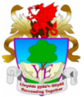
Ysgol Eirias - Blended Learning Guidance
Distance learning will remain the predominant mode of education for our learners for quite some time. From 29th June this will now begin to be blended with face-to-face ‘check-ins’ with the initial purpose of supporting ‘learning fitness’.
Preparing learners for learning fitness
Face-to face learning should focus on undertaking activities which develop our learners’ readiness for learning and begins to reintroduce learning that prepares them to make progress and prepares them for their next steps. Learners will need time and support to develop their readiness for learning. At this point, while the curriculum requirements have been dis-applied, support should focus on learners’ next steps for progression (rather than trying to ‘catch up’ or ‘cover’ areas of the curriculum that have been missed). Teachers own professional judgement should be used to best benefit learners as individuals.

‘In school curriculum’ supported by remote learning
The blend of ‘in school’ and ‘out of school’ learning should be driven by a single ‘in school’ curriculum, ensuring coherence for learners. Contact time must be planned carefully and effectively, using remote learning to support it. Contact time should not be spent doing things that learners can do from home. Rather staff should consider how they can empower learners to undertake meaningful investigations and learning experiences at home (including over the summer break). Time at home can give learners opportunity to research, prepare and think, before exploring and consolidating concepts and skills during contact time. See Appendix for an example model of blended learning.
Learners will have a variety of needs, across physical and remote learning and learning will need to be planned to support these, rather than try to carry on with ‘business as usual’. The ethos, principles and guidance of the new Curriculum for Wales should be used to support the current challenges.

Developing an individualised approach
Learning approaches should recognise that existing SoWs were not designed for blended learning. They can, however, be drawn upon as appropriate, to design a subject specific blended learning offer. The purposes and principles set out in the new curriculum and the new curriculum guidance as a whole should also be used to inform planning. Each subject area should record their own intended learning approach on the ‘Blended-Learning – Curriculum Offer’ template.

The following questions should be considered when making decisions about blended learning approaches:
- What support do learners need to be able to build their learning fitness?
- How can we prepare learners most effectively for the blended approach to learning that they will be experiencing?
- Are there key experiences that are essential for particular year groups that have not yet been undertaken?
- Is any additional support for literacy, numeracy and digital skills necessary to prepare for the coming year?
- What are the immediate needs of learners whose language at home is different to the language used at school?
- How can learning undertaken at home to date be recognised and celebrated?
- How can we prepare learners for learning at home during the summer break?

Assessment
The current role of assessment is to support each individual learner as they re-engage with learning in what will continue to be an unfamiliar context. Assessment should help to identify next steps for learners to enable them to be ready to learn and to make progress in their learning.
Assessment should contribute to developing a holistic picture of the learner in order to identify and support their next steps. In this context, communication between staff and learners (and parents) is key to ensuring well-being. Any feedback provided should focus on supporting the learner to move forward by reassuring them, acknowledging effort and achievement and helping to identify next steps. Referencing ‘missed work’ or ‘falling behind’ is not helpful or appropriate in this situation.
This guidance on assessment is essential to support all learners, including those in Year 10 and Year 12 currently studying for qualifications. They will have specific concerns when they return to the school environment this summer term and their mental, emotional and physical well-being will be our first and foremost priority during this time.
Appendix
The ‘Flipped Learning’ model:
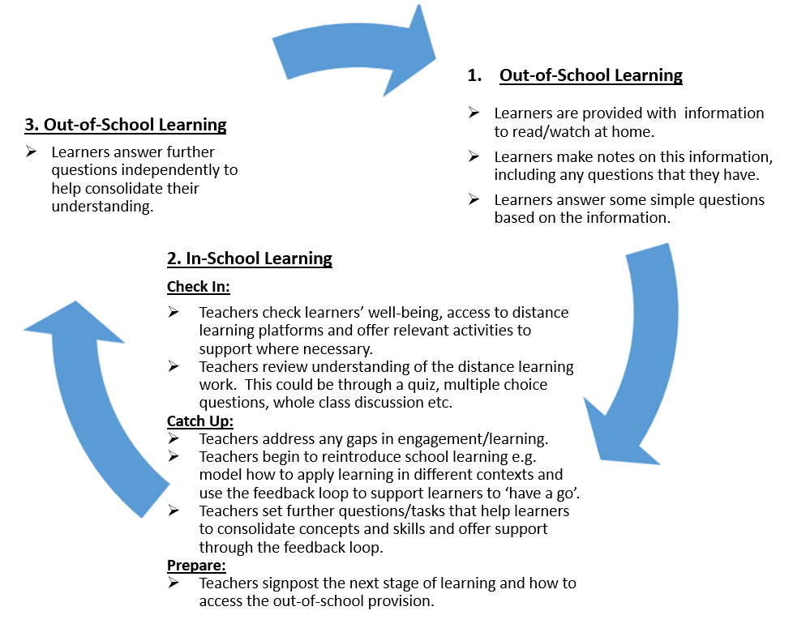
Well-being:
The well-being of our learners has always been a core part of teaching and learning at Ysgol Eirias. Engagement in deep and satisfying learning can provide necessary respite from many of the pressures that our learners are facing. Supporting them with their next steps, reassuring them and focusing on effort and achievement will all have a positive input to the well-being of our learners.

In addition, staff should feel confident to engage in well-being activities with their groups of learners. Now, more than ever, it is important to support our learners to progress in the following areas:
- Resilience
- Self-motivation
- Fears & anxiety
- Social skills – relationships with both peers and adults
Any concerns about the well-being of individual learners should be reported to the relevant HoL (or EC if there is concern about a child protection issue).

