Introduction: What is ‘Conscientious Objection’?

During the First World War (1914-18) and Second World War (1939-45), some people refused to serve in the Armed Forces on grounds of ‘conscience’. They were known as Conscientious Objectors(CO’s).
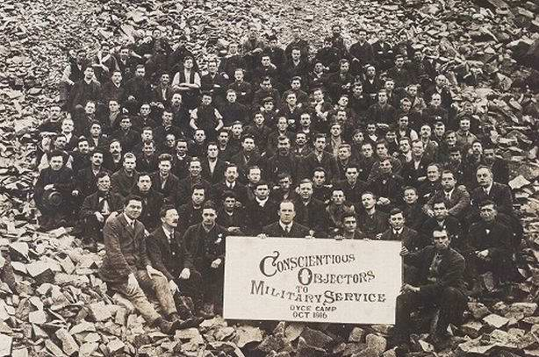
In this Wales for Peace Thematic Pack, you will learn about who they were, why they would not serve, and what happened to them.

We’ll also look at Conscientious Objection in the world today, and set you some challenges to help you understand about how people respond when asked to do something which goes against their conscience.
COS at Dyce Camp – Wikimedia Commons

The Oxford English Dictionary defines ‘conscience’ as:

“A person's moral sense of right and wrong, viewed as acting as a guide to one's behaviour.”

So... your conscience is your view of what’s right and wrong.

Conscientious Objection is usually defined as ‘refusal on moral or religious grounds to serve in the armed forces or to bear arms in a military conflict’.

The term first came to public notice during World War 1.

Note that it isn’t only on religious grounds that people object to war: they also object on humanitarian grounds, on grounds of human rights and international law, and of course on purely political grounds.

And some people object on moral grounds to other issues, such as abortion, though we deal only with war in this Pack.

Activities

- Look at the PowerPoint slides (reproduced courtesy of the National Library of Wales). Discuss: what do you think of the way COS were treated in WWI? Was if fair?

- Your teacher will explain a situation to the class. Put yourself in the shoes of the young person in this situation. What do you think your conscience would tell you to do? What if circumstances changed? Would you behave differently? After doing the exercise discuss as a class.

- Hold a class debate – for and against the motion: “People should have the right to refuse to fight in a time of war
Other resources:

You can find more information and stories about COs in Wales on the Wales for Peace website.

On the WCIA Voices Blog-site you can read the moving stories of CO’s from Wales, including particular stories about COs in Cardiff.

Some individuals you could find out about are: Ithel Davies, George M Ll Davies, Emrys Hughes and Niclas y Glais.

The Pearce Register is a list of the more than 16,000 men from the UK who refused to fight in WWI. It has been compiled by Bert Pearce formerly of Sheffield University. You can search the list and find out about people who lived in your area.

Visit the Peace Pledge Union (PPU) website for lots of information and learning resources.

Voices of Conscience https://hwb.gov.wales/resources/resource/e7a67ebd-356e-4fb5-be5a-955a0d03d600. 6 short films about conscientious objectors in Wales, produced by South Wales Quakers, with follow-up activities.

Standing up for your beliefs https://hwb.gov.wales/resources/resource/9063a670-9d71-4706-b972-11ef774cd510/en A Wales for Peace pack for primary learners with lots of ideas for interactive activities.

Conscience and Choice https://hwb.gov.wales/resources/resource/87f77bd7-9339-4512-810e-424baa1cfd6a/en. A Wales for Peace pack for secondary learners, suitable for history and Welsh Bac learners.

