

The Message of Peace and Goodwill
Its History and Inspiration
Learning Objectives:
By the end of this introduction learners will:
- Know more about an important aspect of Wales’ peace heritage
- Know more about some organisations that aim to promote international peace and understanding, and have considered their potential and their limitations.
- Have considered how to communicate effectively to share messages and ideas.

Introduction for Teachers:
Imagine that you feel so strongly about something that you want to share it with the whole world! This is how Reverend Gwilym Davies must have felt in 1922 when he broadcast the first ever Message of Peace and Goodwill from the children of Wales to the children of the world, using wireless telegraphy. Unfortunately that first message didn’t get very far, but it was picked up by the director of the Eiffel Tower radio station, who forwarded it on in French.
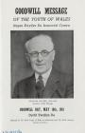
So who was Reverend Gwilym Davies and why did he want to send this message? A Welsh Baptist Minister from Cwm Rhymney, he gave up active ministry in 1922 to work for world peace. He played an important role in setting up the Welsh Union of the League of Nations and UNESCO (the United Nations Educational, Scientific and Cultural Organisation). He felt particularly strongly that education and the voice of children and young people were important in creating international peace and understanding. The message was a way of bringing children and young people from different countries and cultures together and helping them to communicate and share views with one another.
Despite the early disappointment, Gwilym Davies was not one for giving up easily! In 1924, after the BBC broadcast the message for the first time, two responses were received, one from Sweden and the other from Poland. The response rate increased and by 1927, Nobel Peace Prize winner, Dr Nansen, noted: “I feel convinced that it is the spirit in this message of the children of Wales which humanity needs.”
Within a decade, 68 countries had responded. Even during the Second World War the annual message was broadcast without fail, although responses were few and far between. Old contacts were revived after the war, however, and new contacts flourished. In 1946 the following message was received from young people in Germany: “It is years since we have heard from the Welsh Children. How it grew dark! We should like to hear from you again.”
In addition to the Message of Peace and Goodwill, youth peace camps were held in Wales and overseas trips were arranged to enhance cultural exchange and international understanding.
Initially facilitated by the Welsh League of Nations Union at the Temple of Peace, the responsibility for creating and disseminating the Message passed to Urdd Gobaith Cymru, the Welsh Youth Movement, in 1956.
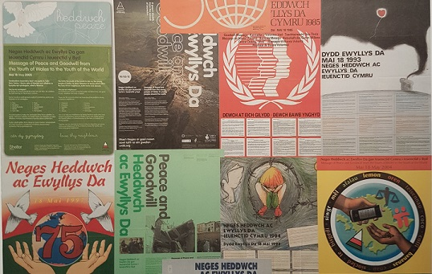
The Message has changed and evolved over the years. More or less identical wording was used in the early messages, (e.g. from 1922 to 1928), with the main effort going into collecting responses. More recent messages have varied greatly in form and presentation, including song, verse and film. Nowadays, the wording and theme of the Message also changes annually, in response to current events, to campaigns by charities and according to issues that young people themselves feel strongly about. However, the aim of the message has remained constant – to enable young people to communicate on themes which are important to them – overcoming barriers of language, culture and politics.
In terms of dissemination, the Message is performed every year on the stage of the Urdd (Young people’s) Eisteddfod and in the Senedd building, and broadcasted on radio and television. It is translated into as many languages as possible, and made available on the Urdd’s website, and a poster with the message in different languages is distributed to every school in Wales. However, considering the huge variety of channels of communication now available to us, is the Message as well-known or effective as it could be? A key aim of this pack is to support schools in uncovering this important element of Wales’ peace heritage and to consider how they can use the Message annually to inspire learning and action, encouraging learners to become ‘ethical, informed citizens of Wales and the world’ (Professor Graham Donaldson, 2016) – one of the four purposes of the curriculum in Wales.

Presentation:
- Introduce the key points of the story of the Message of Peace and Goodwill using the PowerPoint presentation, or
- Tell the story in your own words
Response Activities
- Run the quiz, or divide learners into teams and organise a quiz to test one another
- Find out about the Welsh League of Nations and UNESCO. What organisations aim to promote peace and understanding at the international level today? To what extent are they successful? (KS3 - 4)
- What is wireless telegraphy? How has communication developed over the years since 1922? Do you think that communication today is more effective? Are there drawbacks to having too much information?
- Discuss: if you had an important message you wanted to get out to as many people as possible today, how would you send it?

Sources
- History and background of the Message of Peace and Goodwill on Wales for Peace website
- An interactive timeline of the Message by Wales for Peace volunteer Mailys
- Urdd Message of Peace and Goodwill on People’s Collection Wales
- Past Messages of Peace and Goodwill (from 2010) on Urdd website
- Grid showing messages over the years – main themes and responses

